California Public Utilities Commission Energy Division Staff Comments on CAISO’s Business Practice Change Proposed Revision Request 1497

The California Public Utilities Commission (CPUC) Energy Division Staff (“ED staff”) appreciates the opportunity to comment on CAISO’s Business Practice Manual (BPM), Proposed Revision Request (PRR) 1497 regarding the designation of exports as firm-provisional. In order to ensure that CAISO has the ability to identify lower-priority LPT exports to curtail during stressed system conditions, CAISO has proposed that they be tagged as “Firm Provisional (G-FP).”
ED staff is concerned that the proposed BPM language is not consistent with the language in its final proposal or in its tariff filing. CAISO’s proposed language is shown below:

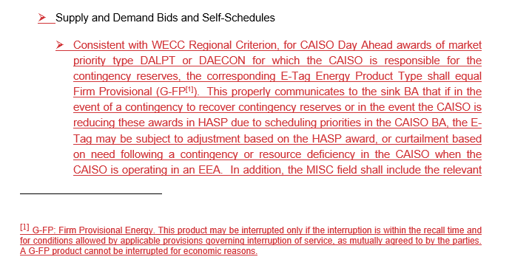
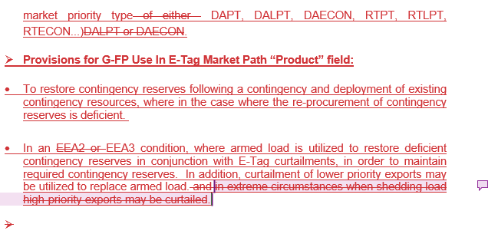

This proposed language could be interpreted to mean CAISO will only curtail exports when it is in an EEA3 condition, where armed load is utilized to restore deficient contingency reserves or to replace armed load.
However, this interpretation would be inconsistent with CAISO’s Final Proposal, which states that, subject to operator judgement and consistent with good utility practice, this would occur before an EEA3 when CAISO is unable to meet its load and reserve obligations:
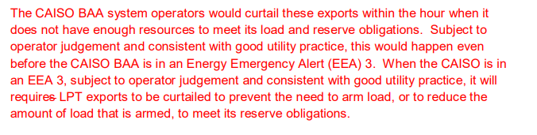
The language in CAISO’s BPM does not appear to contemplate curtailing exports post-HASP to meet its load and reserve obligations before an EEA 3. This is inconsistent with CAISO’s proposed tariff which appears to contemplate curtailing LPT exports post-HASP before an EEA 3, subject to operator judgement and consistent with good utility practice (see attachment to this document). CAISO should revise the language in the BPM to reflect its Revised Final Proposal and tariff language.
Further, CAISO states that it will require lower priority LPT exports to tag as G-FP, “Firm Provisional Energy,” and, in a footnote, indicates that, “[t]his product may be interrupted only if the interruption is within the recall time and for conditions allowed by applicable provisions governing interruption of service, as mutually agreed to by the parties. A G-FP product cannot be interrupted for economic reasons.” It would be helpful if CAISO could clarify what it means by “mutually agreed to by the parties” and whether this in any way over-rides CAISO’s proposed tariff authority to manually curtail LPT exports at its sole discretion, as specified in Section 34.12.4.

Attachment – CAISO’s Proposed Tariff
34.12.4
At its sole discretion, the CAISO may, after HASP, apply the market scheduling run priorities in Section 34.12.1 through manual operator intervention to curtail lower priority HASP hourly block export schedules even before the CAISO Balancing Authority Area is in an energy emergency alert. When the CAISO is in an emergency alert level 3 (EEA 3), subject to operator judgement and consistent with good utility practice, it will curtail in accordance with the priority specified below to prevent the need to arm Load, or reduce the amount of Load that is armed, and meet its operating reserve obligations. For purposes of this section, the CAISO would curtail lower priority exports in the following order:
(a) Real-Time economic hourly block export schedules that cleared HASP,
(b) Real-Time Self-Schedule hourly block export schedules not backed by Generation from non-Resource Adequacy Capacity and cleared HASP, then
(c) Day-Ahead hourly block export schedules not backed by Generation from non-Resource Adequacy Capacity that also cleared HASP
To accommodate curtailment of lower priority exports in the order set forth above, the CAISO will consider any schedule to export energy, other than an export backed by Generation from non-Resource Adequacy Capacity, as firm provisional energy. A Scheduling Coordinator’s failure to comply with the tagging requirements specified in the Business Practice Manual for any export schedule other than an export backed by Generation from non-Resource Adequacy Capacity will result in a default to the priority specified in (a) above (e.g., will be curtailed in the same tranche as the Real-Time economic hourly block export schedules that cleared HASP).

SecondRevisedFinalProposal-WEIMResourceSufficiencyEvaluationEnhancementsPhase2.pdf (caiso.com), p. 18.

